**OOPJ**

**Assignment No- 2**

1)Write a program that checks if a given year is a leap year or not using both if-else and switch-case.

**Code:** import java.util.*;

public class LeapYear {

public static void main(String... args) {

Scanner sc = new Scanner(System.***in***);

System.***out***.print("Enter year: ");

int year = sc.nextInt();

sc.close();

boolean isLeapYear = false;

if(year % 4 == 0) {

isLeapYear = true;

if(year % 100 == 0) {

if(year % 400 == 0) {

isLeapYear = true;

}

else {

isLeapYear = false;

}

}

}

else {

isLeapYear = false;

}

if(isLeapYear == true)

System.***out***.println(year + " is a leap year.");

else System.***out***.println(year + " is not a leap year.");

}

}

o/p:

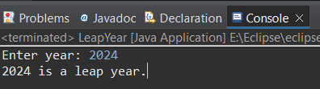

2)Implement a program that calculates the Body Mass Index (BMI) based on height and weight input using if-else to classify the BMI int categories (underweight, normal weight, overweight,etc).

**Code:**

import java.util.*;

public class BMI_Calculator {

public static void main(String...args) {

Scanner sc = new Scanner(System.***in***);

System.***out***.print("Enter your weight: ");

float weight = sc.nextFloat();

System.***out***.print("Enter your height: ");

float height = sc.nextFloat();

sc.close();

float bmi = weight / (height * height);

if(bmi < 18.5) {

System.***out***.println("Your BMI is: " + bmi + ", You are underweight.");

}

else if(bmi >= 18.5 && bmi < 24.9) {

System.***out***.println("Your BMI is: " + bmi + ", Your BMI is Normal.");

}

else if(bmi >= 25 && bmi < 29.9) {

System.***out***.println("Your BMI is: " + bmi + ", You are Overweight.");

}

else {

System.***out***.println("Your BMI is: " + bmi + ", You are Obese.");

}

}

}

o/p:

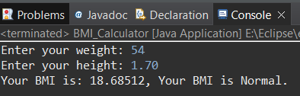

3)Write a program that checks if a person is eligible to vote based on their age.

**Code:**

import java.util.*;

public class EligibleVoter {

public static void main(String[] args) {

Scanner sc = new Scanner(System.*in*);

System.*out*.print("Enter your age: ");

int age = sc.nextInt();

sc.close();

if(age < 18)

System.*out*.println("Your are not eligible to vote.");

else

System.*out*.println("Your eligible to vote.");

}

}

o/p:

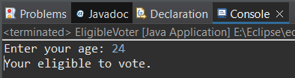

4)Write a program that takes a month (1-12) and prints the corresponding season (Winter, Spring, Summer, Autumn) using a switch case.

**Code:**

import java.util.Scanner;

public class Season {

public static void main(String[] args) {

Scanner sc = new Scanner(System.***in***);

System.***out***.print("Enter month : ");

int month = sc.nextInt();

sc.close();

String season;

switch (month) {

case 12:

case 1:

case 2:

season = "Winter";

break;

case 3:

case 4:

case 5:

season = "Spring";

break;

case 6:

case 7:

case 8:

season = "Summer";

break;

case 9:

case 10:

case 11:

season = "Autumn";

break;

default:

season = "Invalid month";

break;

}

System.***out***.println("The season is: " + season);

}

}

o/p:

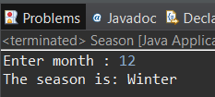

5)Write a program that allows the user to select a shape (Circle, Square, Rectangle, Triangle) and then calculates the area based on user-provided dimensions using a switch case.

**Code:**

package Java_Practice;

import java.util.*;

public class Area {

public static void main(String[] args) {

Scanner sc = new Scanner(System.***in***);

double area;

double pi = 3.14;

int shapeNo;

do {

System.***out***.println("Choose any shape to find area: ");

System.***out***.println("0. Exit 1. Circle 2. Square 3. Rectangle 4. Triangle.");

shapeNo = sc.nextInt();

switch (shapeNo) {

case 1:

System.***out***.println("Enter radius of circle: ");

int r = sc.nextInt();

area = pi * r * r;

System.***out***.println("Area of circle is: " + area + "\n");

break;

case 2:

System.***out***.println("Enter side of square: ");

int s = sc.nextInt();

area = s * s;

System.***out***.println("Area of square is: " + area + "\n");

break;

case 3:

System.***out***.println("Enter length of rectangle: ");

int l = sc.nextInt();

System.***out***.println("Enter breadth of rectangle: ");

int b = sc.nextInt();

area = l * b;

System.***out***.println("Area of rectangle is: " + area + "\n");

break;

case 4:

System.***out***.println("Enter base of triangle: ");

int base = sc.nextInt();

System.***out***.println("Enter height of triangle: ");

int height = sc.nextInt();

area = (base * height) / 2;

System.***out***.println("Area of triangle is: " + area + "\n");

break;

default:

System.***out***.println("Invalid shape number, Please enter between 1 and 4.");

break;

}

} while(shapeNo != 0);

sc.close();

}

}

o/p:

